**Week 9 Lab Assembler - DifferentInputs**

**Group 65**

**Integrants: 110504517 李睿穎 (Leader)，110504518 鍾秉均 (Member)**

**Full Code**

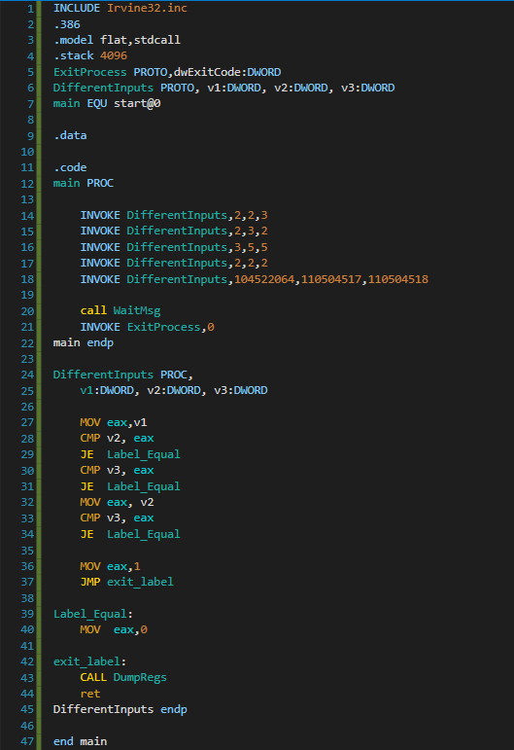

**Explanation**

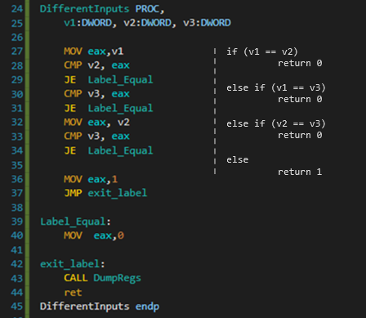

**Print Result**

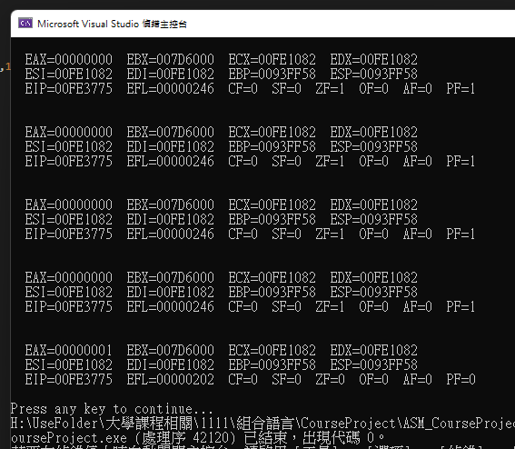

**Reflection**

The first part of this week’s lab was pretty straightforward, we only needed to do three comparisons: comparing first with second number, comparing second with third number and comparing first with third number. We learnt how CMP perforsms a subtraction by seeing the Zero Flag.